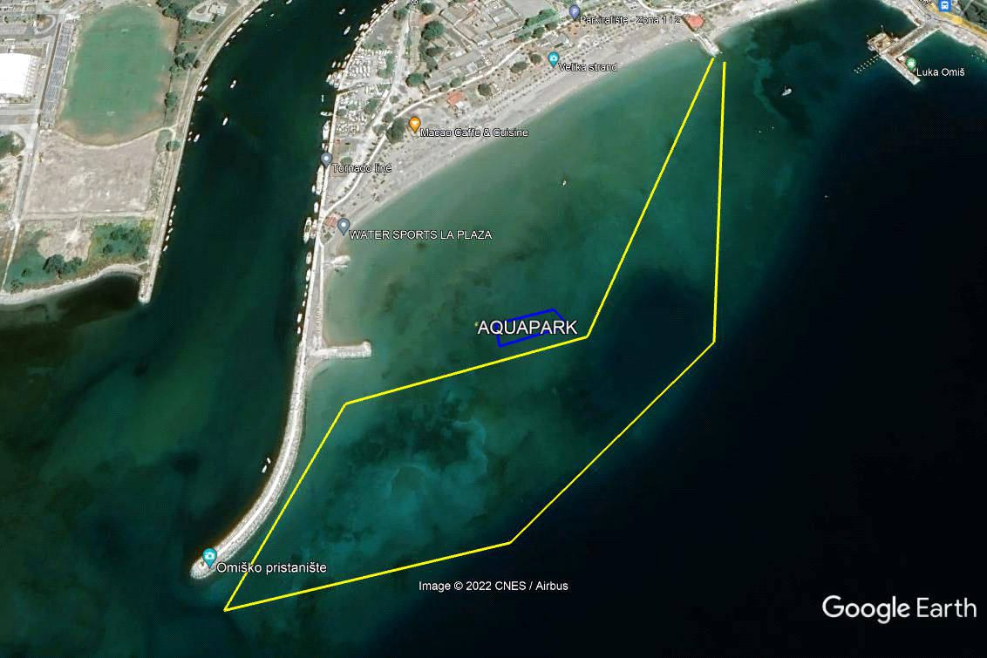
gggggggggggggggggggvvvvvvvvvvv
MALI MARATON
1501 metar
gggggggggggggggggggvvvvvvvvvvv
hgghsghfggnfgnfn

